**Written Examination**

### Why is Java considered platform independent?

### When javac compiles a java program it generates a file with .class extension. Class files contains byte code which can be interpreted only using a JVM, since JVM’s are made available across all platform including the Linux environment which makes Java independent

1. **What are JVM, JRE, and JDK??**

**JVM means Java Virtual Machine and it is a platform dependent which is used to execute the java .class files**

**JRE means Java Runtime Environment, it provides the minimum requirements such as libraries and class loader for executing a Java application on JVM**

**JDK means Java Development Kit, a software development used to develop Java applications.**

1. **What is the difference between ArrayList and vector?**

**Array list are non-synchronized, Vectors are synchronized.**

**Arraylist is not Legacy, Vector is a legacy class**

**Arraylist is faster, Vector is slower**

**Arraylist uses iterator interface to traverse through elements, Vectors used both iterator or enumerator.**

### How do equals() and == differ?

### Equals means it is that set as that value, while == means the set value is compared with another set of value

### Explain public static void main(String args[]) in Java

### That is a keyword specifies that a method doesn’t return anything therefore the return type is void. The java program terminates with the termination of the main method. Java type arguments are stored in a array type string.

### Why Java is not 100% Object-oriented?

### Because it supports primitive data types like long, byte and etc..

### What are wrapper classes in Java?

### Wrapper classes that are dedicated to primitive data types which are presented in “java.lang” package

### What are constructors in Java?

### A special method used to initialize objects in java. We use constructors to initialize all variables in the class when an object is created.

### What is singleton class in Java and how can we make a class singleton?

### A singleton class is a class that can have only one subject at a time.

### To create the singleton class, we need to have static member of class, private constructor and static factory method.

1. **What is a package in Java? List down various advantages of packages.**

**Package is a mechanism to group related classes, interfaces and Enums in to a single module.**

**Advantages of packages: To resolve naming conflicts, to follow OOP concepts properly and for visibility control**

1. **Why pointers are not used in Java?**

**Pointers are unsafe, pointers variables refer address location of data directly**

1. **What** **are access modifiers in Java?**

**Access modifiers are the keywords which are used to define the access scope of the method, class, or a variable.**

1. **What is an object in Java and how is it created?**

**Object is an instance of a class. An object is created based on its class**

1. **What is the difference between a local variable and an instance variable?**

**Instance variable is a variable that is declared in a class but outside a method, while a local variable is a variable declared within a method or a constructor.**

1. **What is final keyword in Java?**

**Final is used to apply restrictions on class, method and variable. Final classes cannot be inherited and final method cannot be overridden and final variables cannot be changed**

1. **Is a finally block executed when an exception is thrown from a try block that does**

**not have a catch block, and if so, when?**

**The finally-block will always execute after the try -block and catch -block(s) have finished executing.**

1. **Draw an ER diagram according to the technical exercise provided**
2. 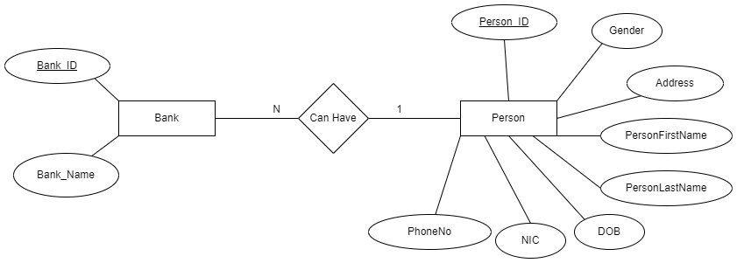**Implement normalization and sample table design for above drawn ER diagram**